# **MetFrag Hands-on - September 25, Monday**

## **Topic:** Using MetFrag for compound identification with MS/MS data and additional information

In this hands-on session you will learn how to use MetFrag to annotate MS/MS spectra as a first step to identify a molecular structure given MS and MS/MS information. Furthermore, we will use additional experimental and meta data to support a putative identification.

## Manual

In this example we have extracted a feature from a water (river) sample from a LC-MS/MS measurement with a precursor m/z 230.1162 at retention time 10.1 minutes. The data is acquired on a LTQ Orbitrap XL with a high mass accuracy (<5ppm) in positive ion mode. The adduct type of the selected precursor ion is known as [M+H]⁺.

Download the file *metfrag_handson_data.zip* from the google drive folder

|  |  |
| --- | --- |
| **Contents** | |
| ms1_mz230.1162_rt10.1.txt | MS1 peak list |
| ms2_mz230.1162_rt10.1.txt | MS2 peak list |
| retentiontime_model/rt_input_PubChem_XlogPs.csv | data for retention time model |

### 

### 

### Step 1 - Run initial MetFrag processing

1 a) Retrieve Candidates from database

* visit the MetFragWeb tool in your browser (<https://msbi.ipb-halle.de/MetFrag>)
* at first the database settings need to be defined to retrieve candidates given the MS1 information
* use the precursor m/z value to calculate the neutral monoisotopic mass

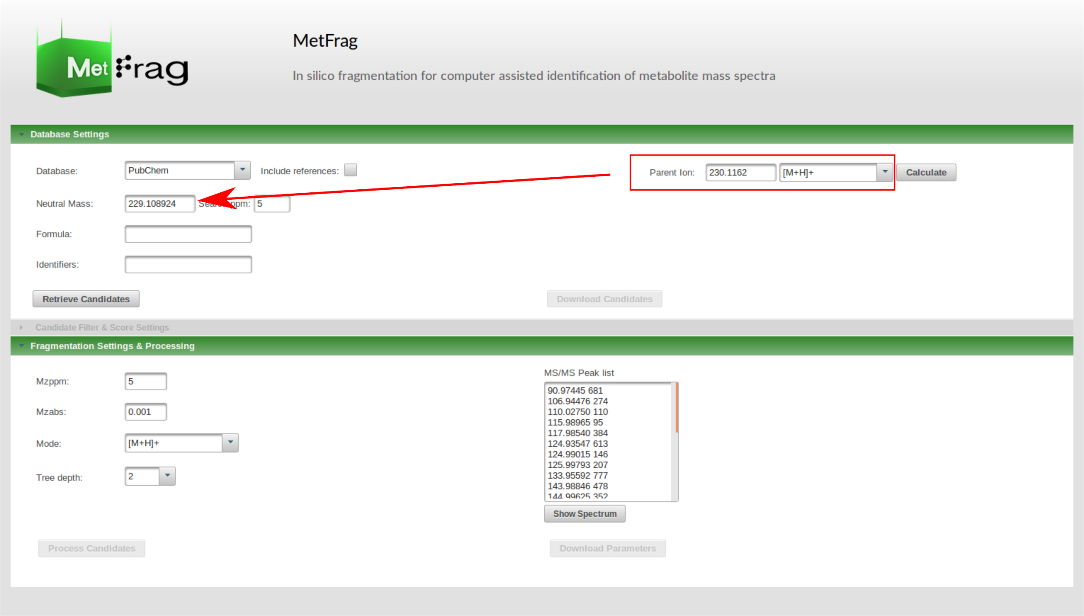

* select PubChem as compound database and start a first candidate retrieval by clicking “Retrieve Candidates”
* MetFrag searches candidates matching the information given by the “Database settings” (here: Neutral Mass and 5 ppm deviation)

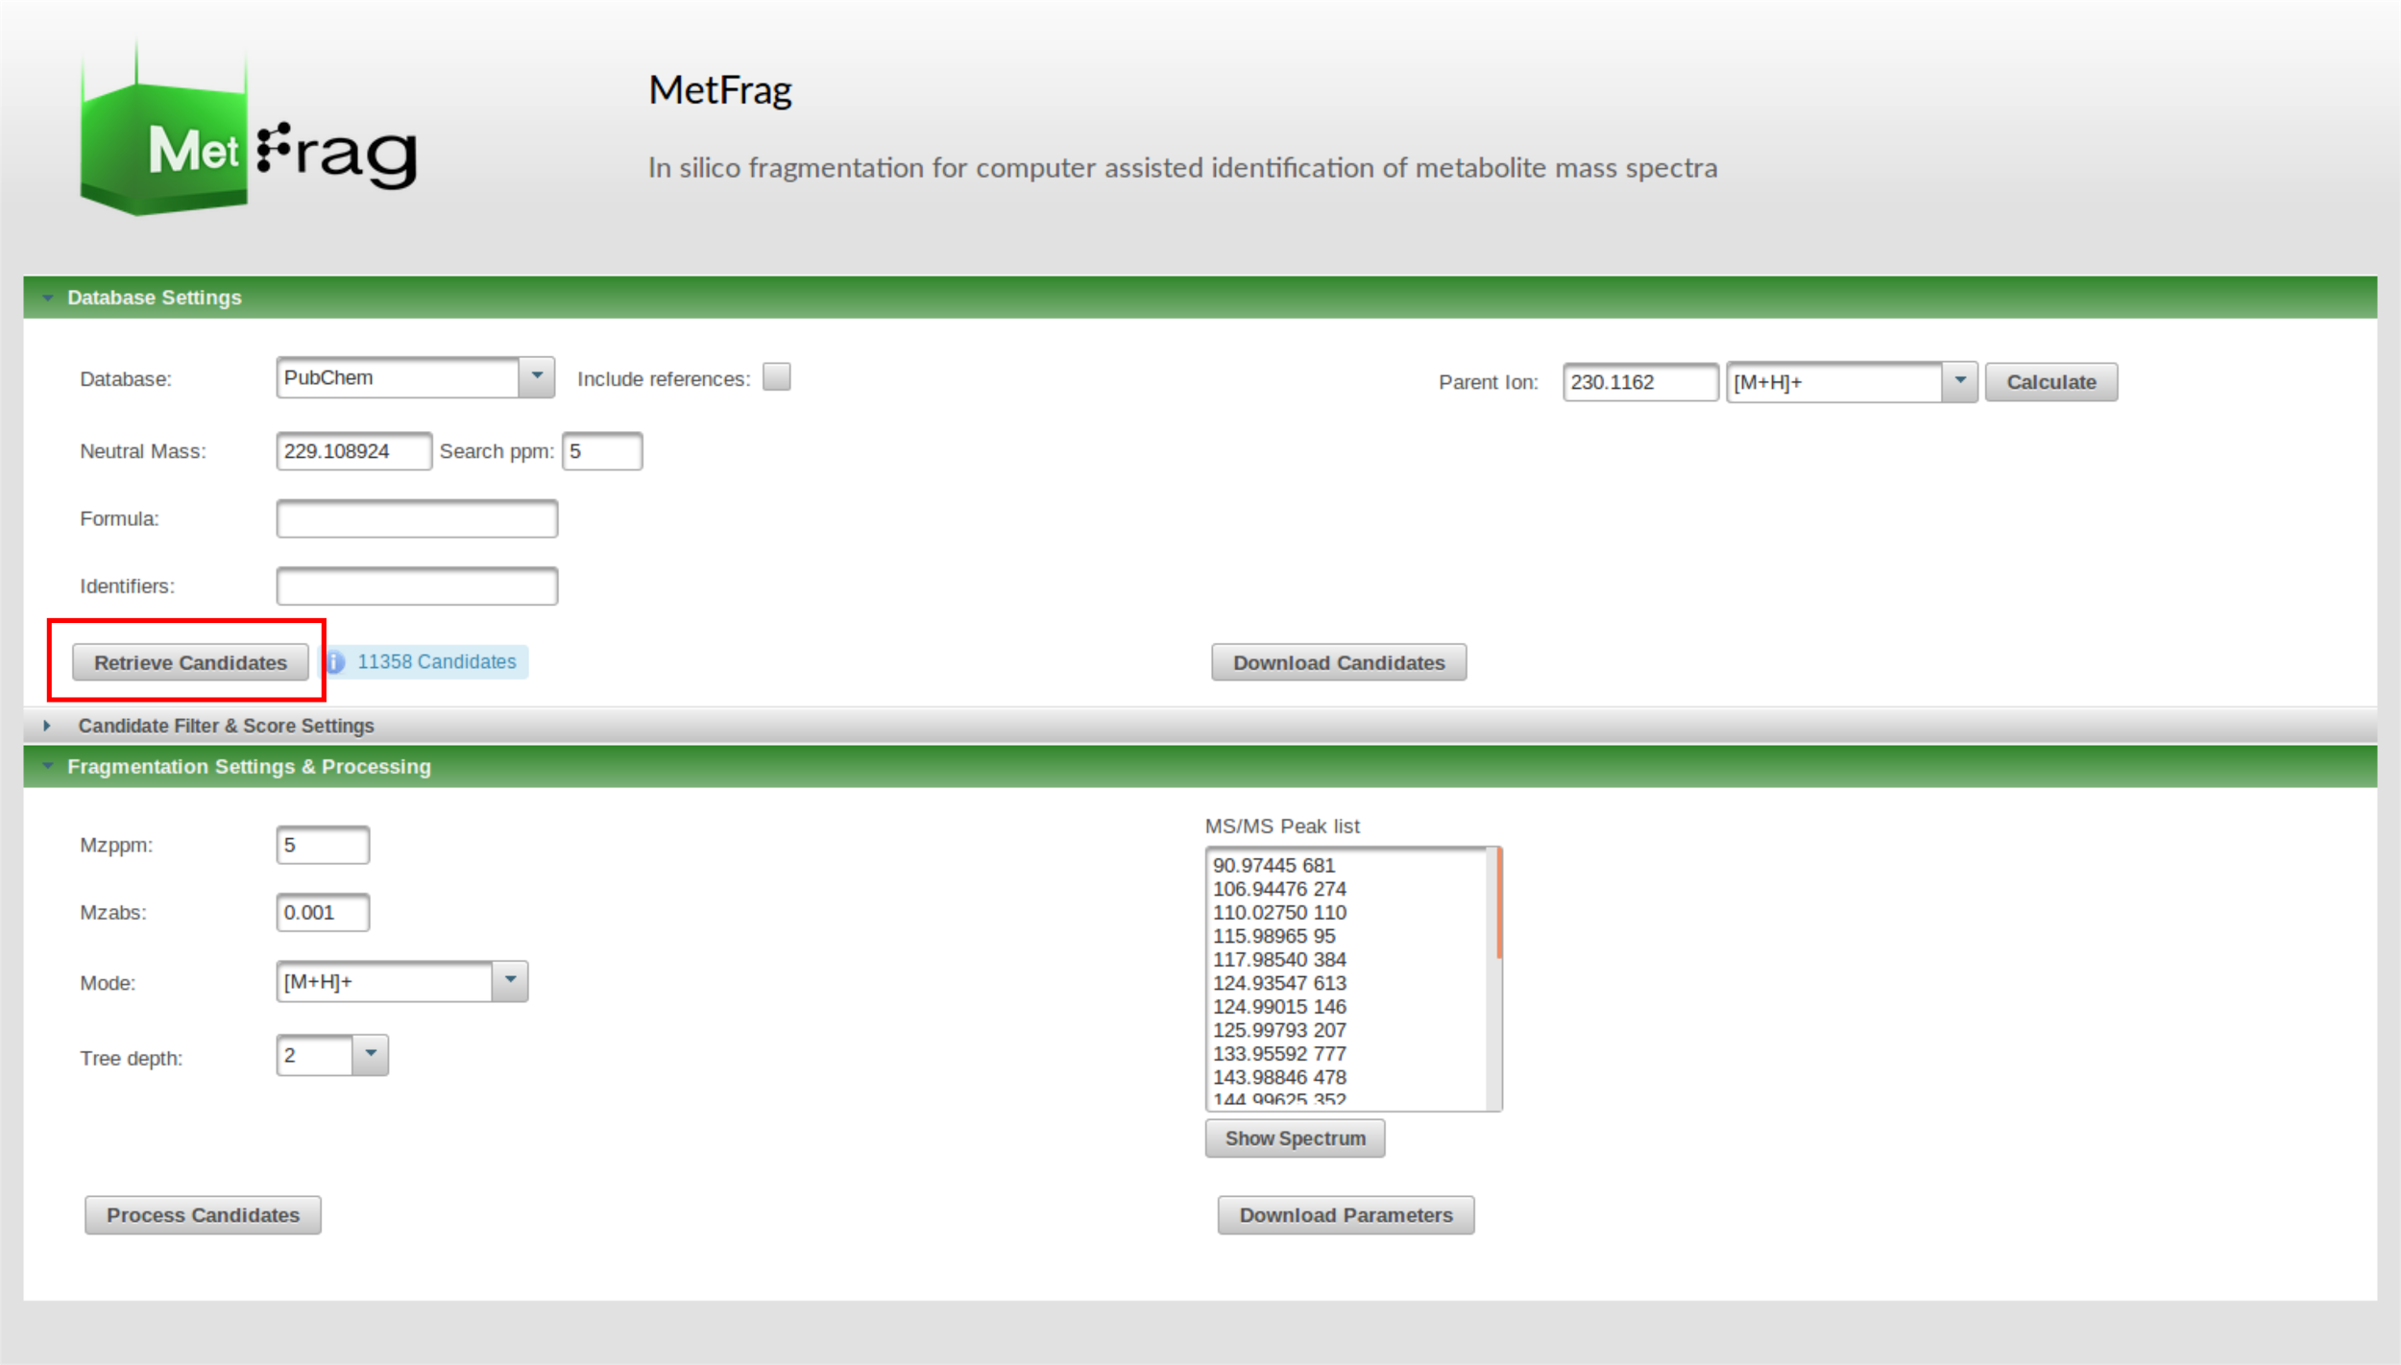

* after the retrieval you can download the candidate list as CSV or XLS to get a first overview about the retrieved data set

1 b) Process candidates by performing *in silico* and matching to MS/MS data

* use the “Fragmentation settings” tab to add the given MS2 peak list

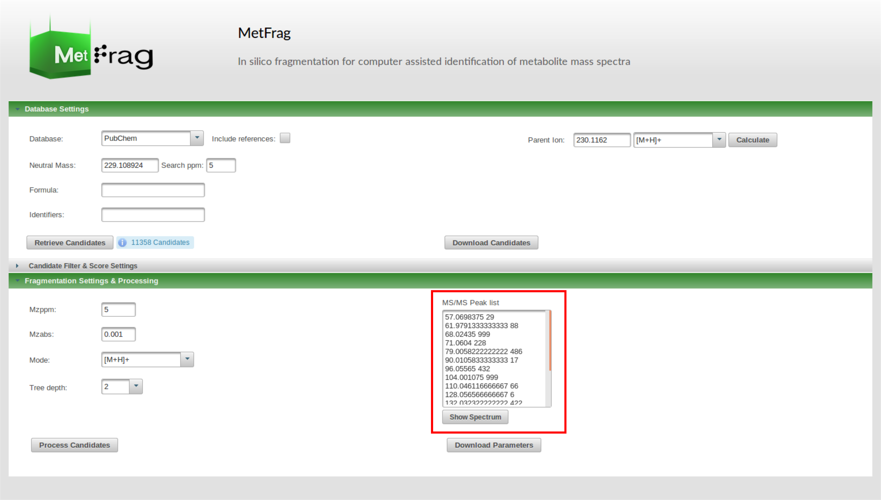

* you can visualize the peak list by clicking on the “Show Spectrum” button

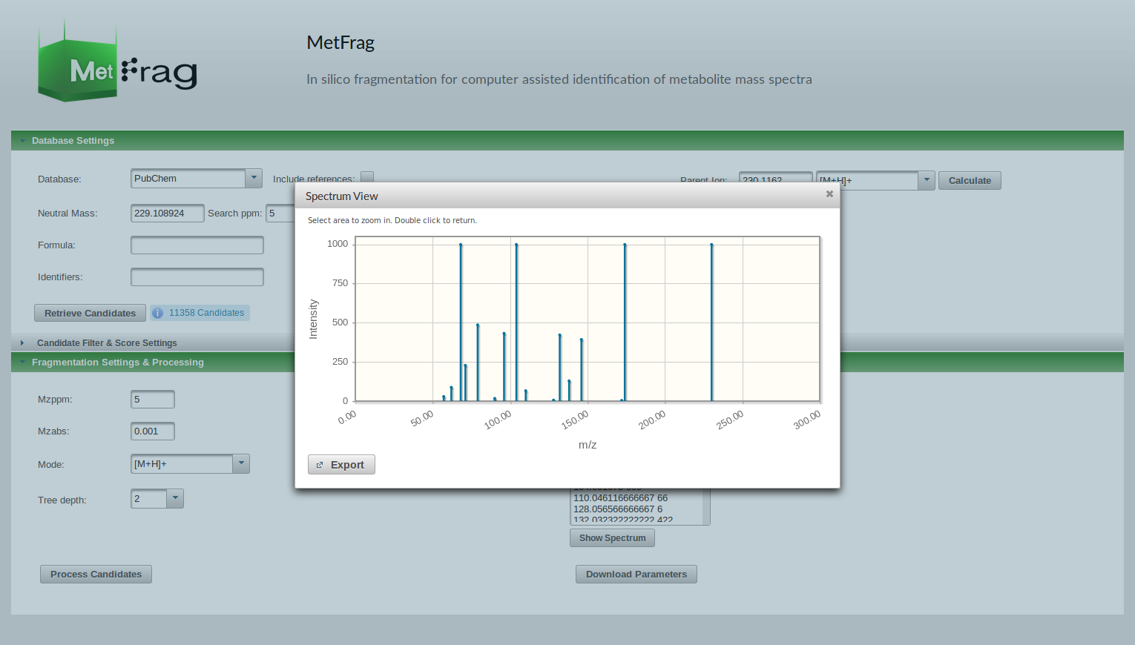

* keep the settings for the *in silico* fragmentation and start the processing by clicking “Process Candidates”
* MetFrag now generates fragments for each candidate up to the specified tree depth
* the fragments are mapped to the MS/MS peak list (based on mass) which is used to calculate a score for each candidate

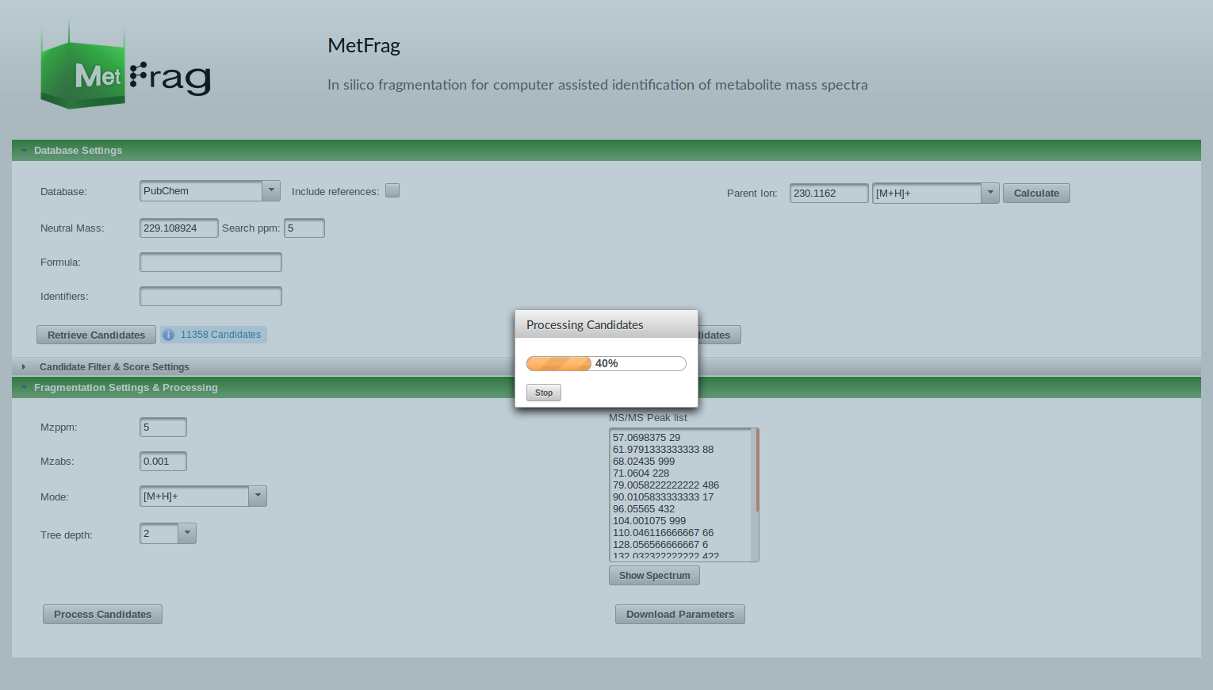

* after the processing is finished you see the ranked candidates list in the “Results” tab
* here you have different possibilities:
  + you can filter candidates by explained peaks
  + investigate explained fragments and calculated scores for each candidate
  + download ranked candidate list

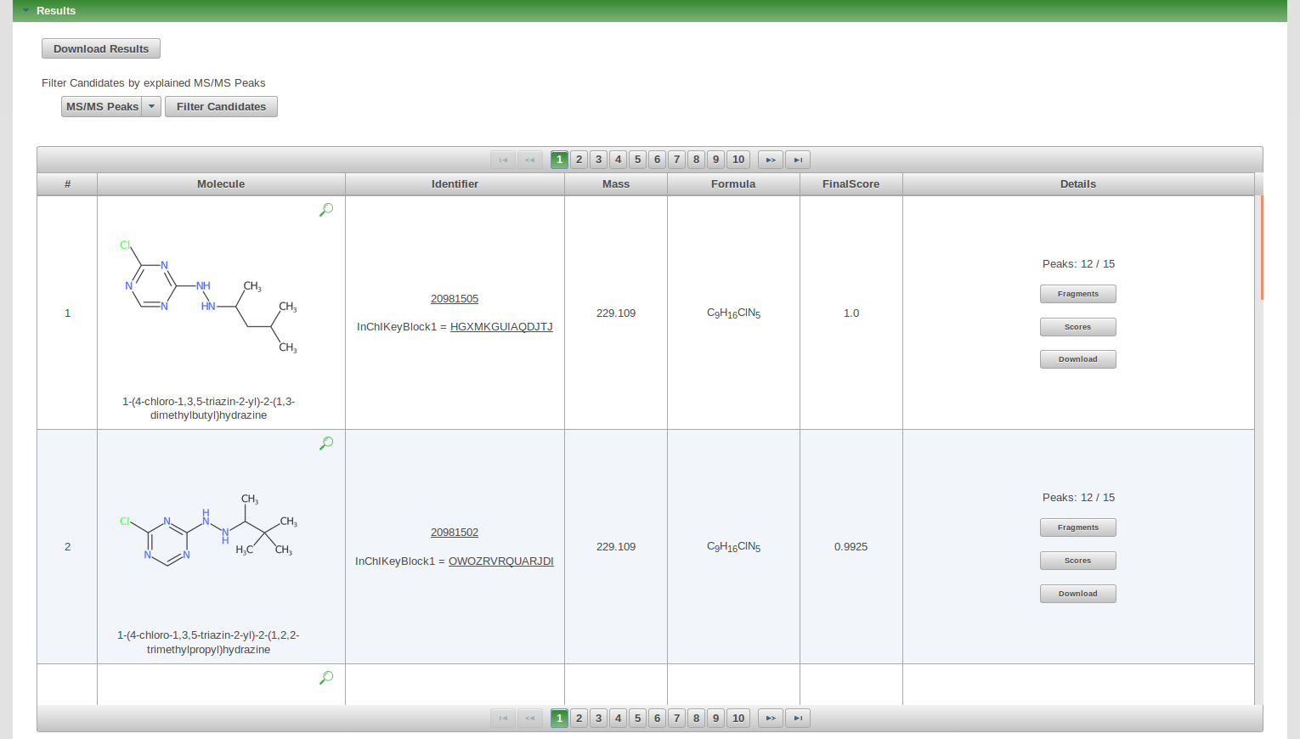

* download the ranked candidate list as CSV or XLS file

**Questions:**

Q1: How many different molecular formulas are present?

Q2: What do you think is the correct molecular formula? What else could you do to verify that besides the given MetFrag results?

### Step 2 - Run MetFrag processing using molecular formula

2 a) Retrieve Candidates from database

* use the same settings as in 1 a) but add the molecular formula
* select “Include references” when using PubChem

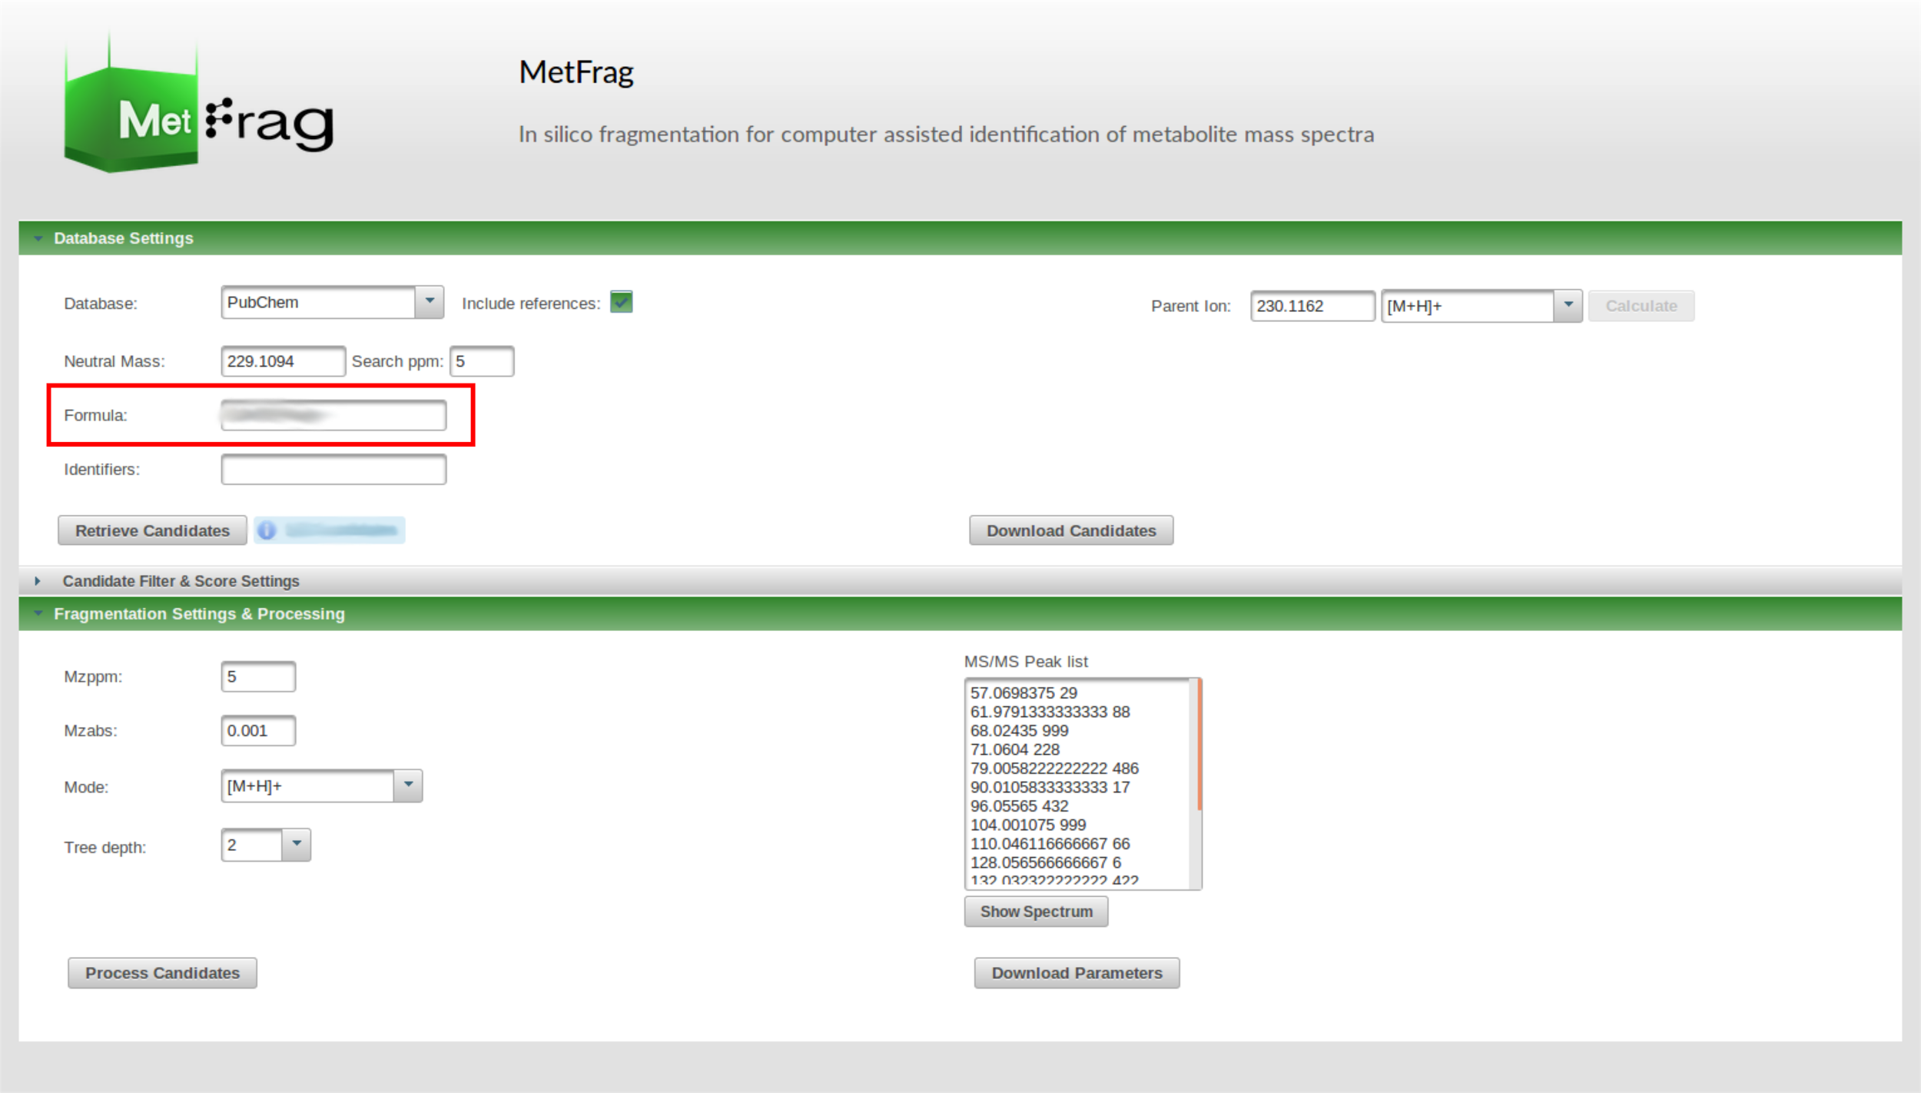

2 b) Process candidates by performing *in silico* fragmentation and matching to MS/MS data

* use the same settings as in 1 b) and process the candidates

**Questions:**

Q3: Looking at the results, what has changed compared to using the monoisotopic mass as candidate filter?

Q4: Is the molecular formula helpful here?

### 

### 

### 

### 

### 

### 

### Step 3 - Run MetFrag adding additional experimental information

3 a) Add the retention time data model to the MetFragWeb tool

* adding additional information available from the experimental context is oftentimes helpful to verify a putative identification
* now we want to add retention time as additional experimental information
* there exist different models to predict retention times
* MetFrag includes a linear model that is usually based on a [logP](https://en.wikipedia.org/wiki/Partition_coefficient) partition

coefficient - retention time correlation

* the file retentiontime_model/rt_input_PubChem_XlogPs.csv contains a data set of measured retention times and [XLogP3](https://www.ncbi.nlm.nih.gov/pubmed/17985865) values of 254 Eawag standards:

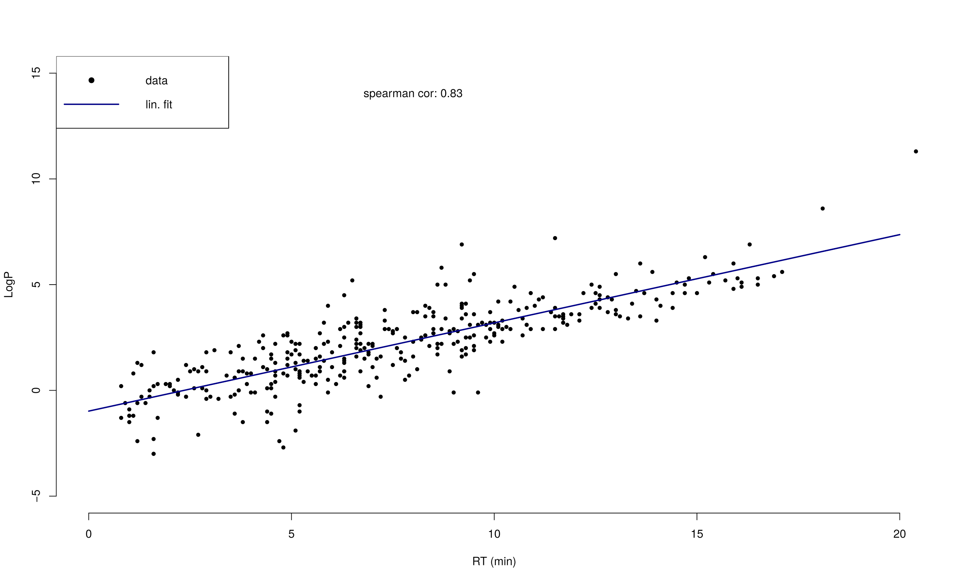

* upload the data set to the MetFragWeb tool in the “Candidate Filter & Score Settings” tab using the “Retention Time” panel on the right side

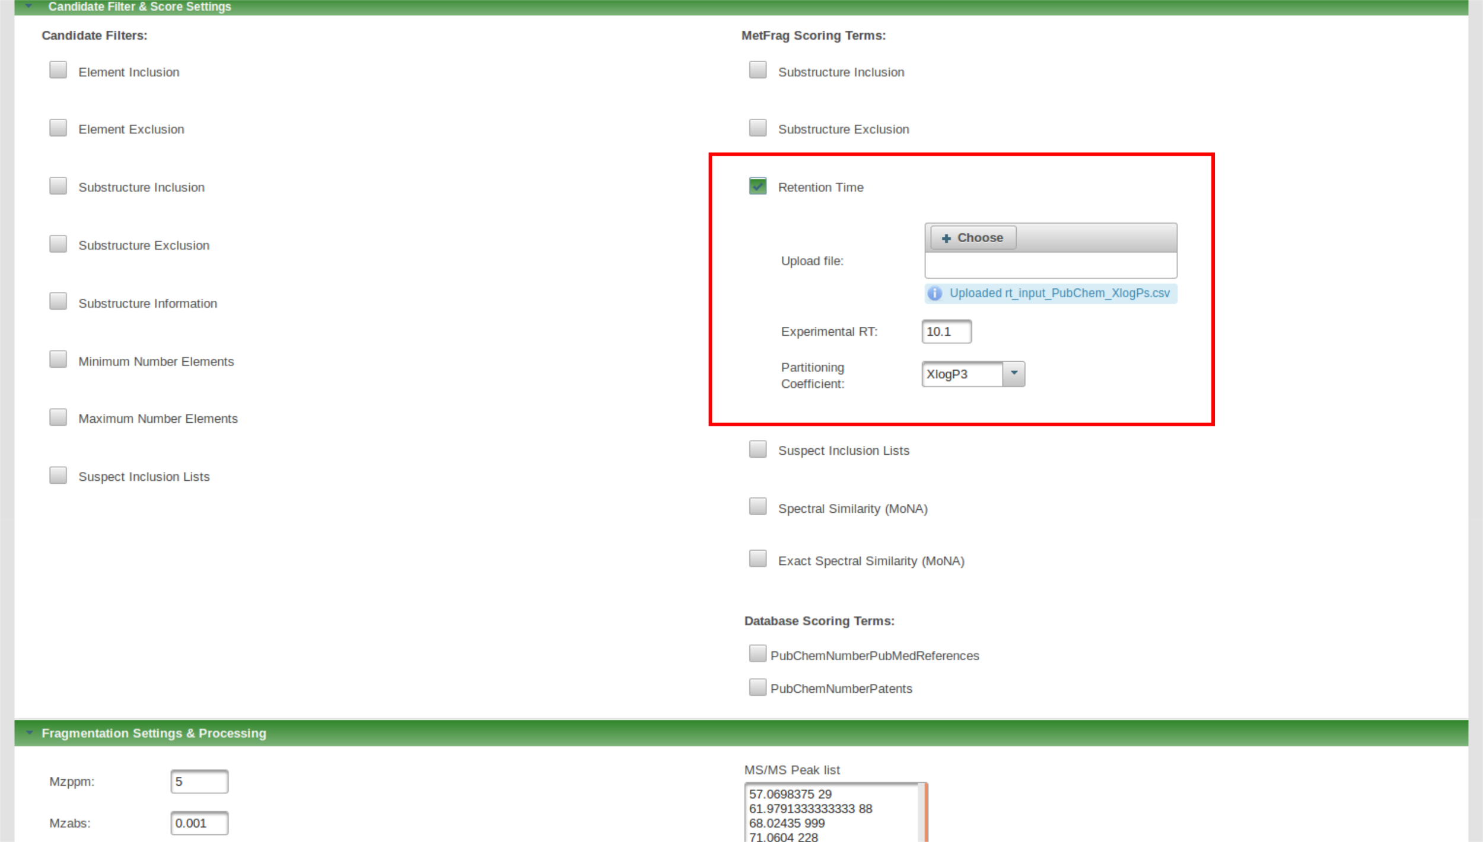

* after the file upload set the retention time of the precursor and select XLogP3 as partition coefficient which is used for correlation
* this results in an additional scoring term in the scoring function of MetFrag

3 b) Process candidates by performing *in silico* fragmentation and matching to MS/MS data

* use the same settings as in 2 b) and process the candidates

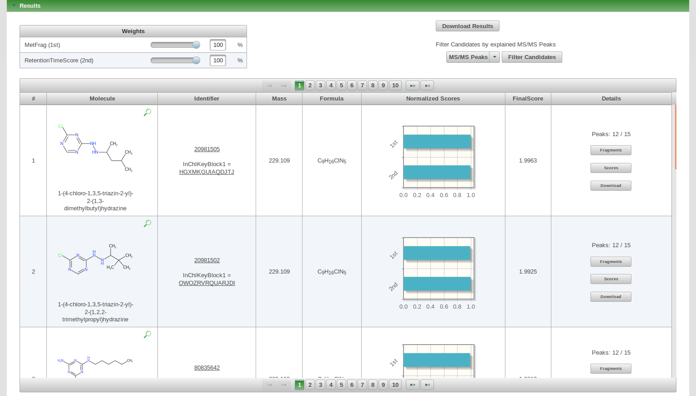

**Questions:**

Q5: What has changed compared to the previous run?

Q6: Use the weight sliders in the “Results” tab. Does it change anything?

Q7: Is the retention time information helpful here?

### 

### 

### Step 4 - Run MetFrag adding additional meta information

4 a) Add the additional scoring terms

* meta information can help to verify putative identifications depending on the experimental context
* however, you need to be careful when using this information which is not related to your acquired data
* in the “Candidate Filter & Score Settings” tab select the additional “Database Scoring Terms”
  + PubChemNumberPubMedReferences
  + PubChemNumberPatents

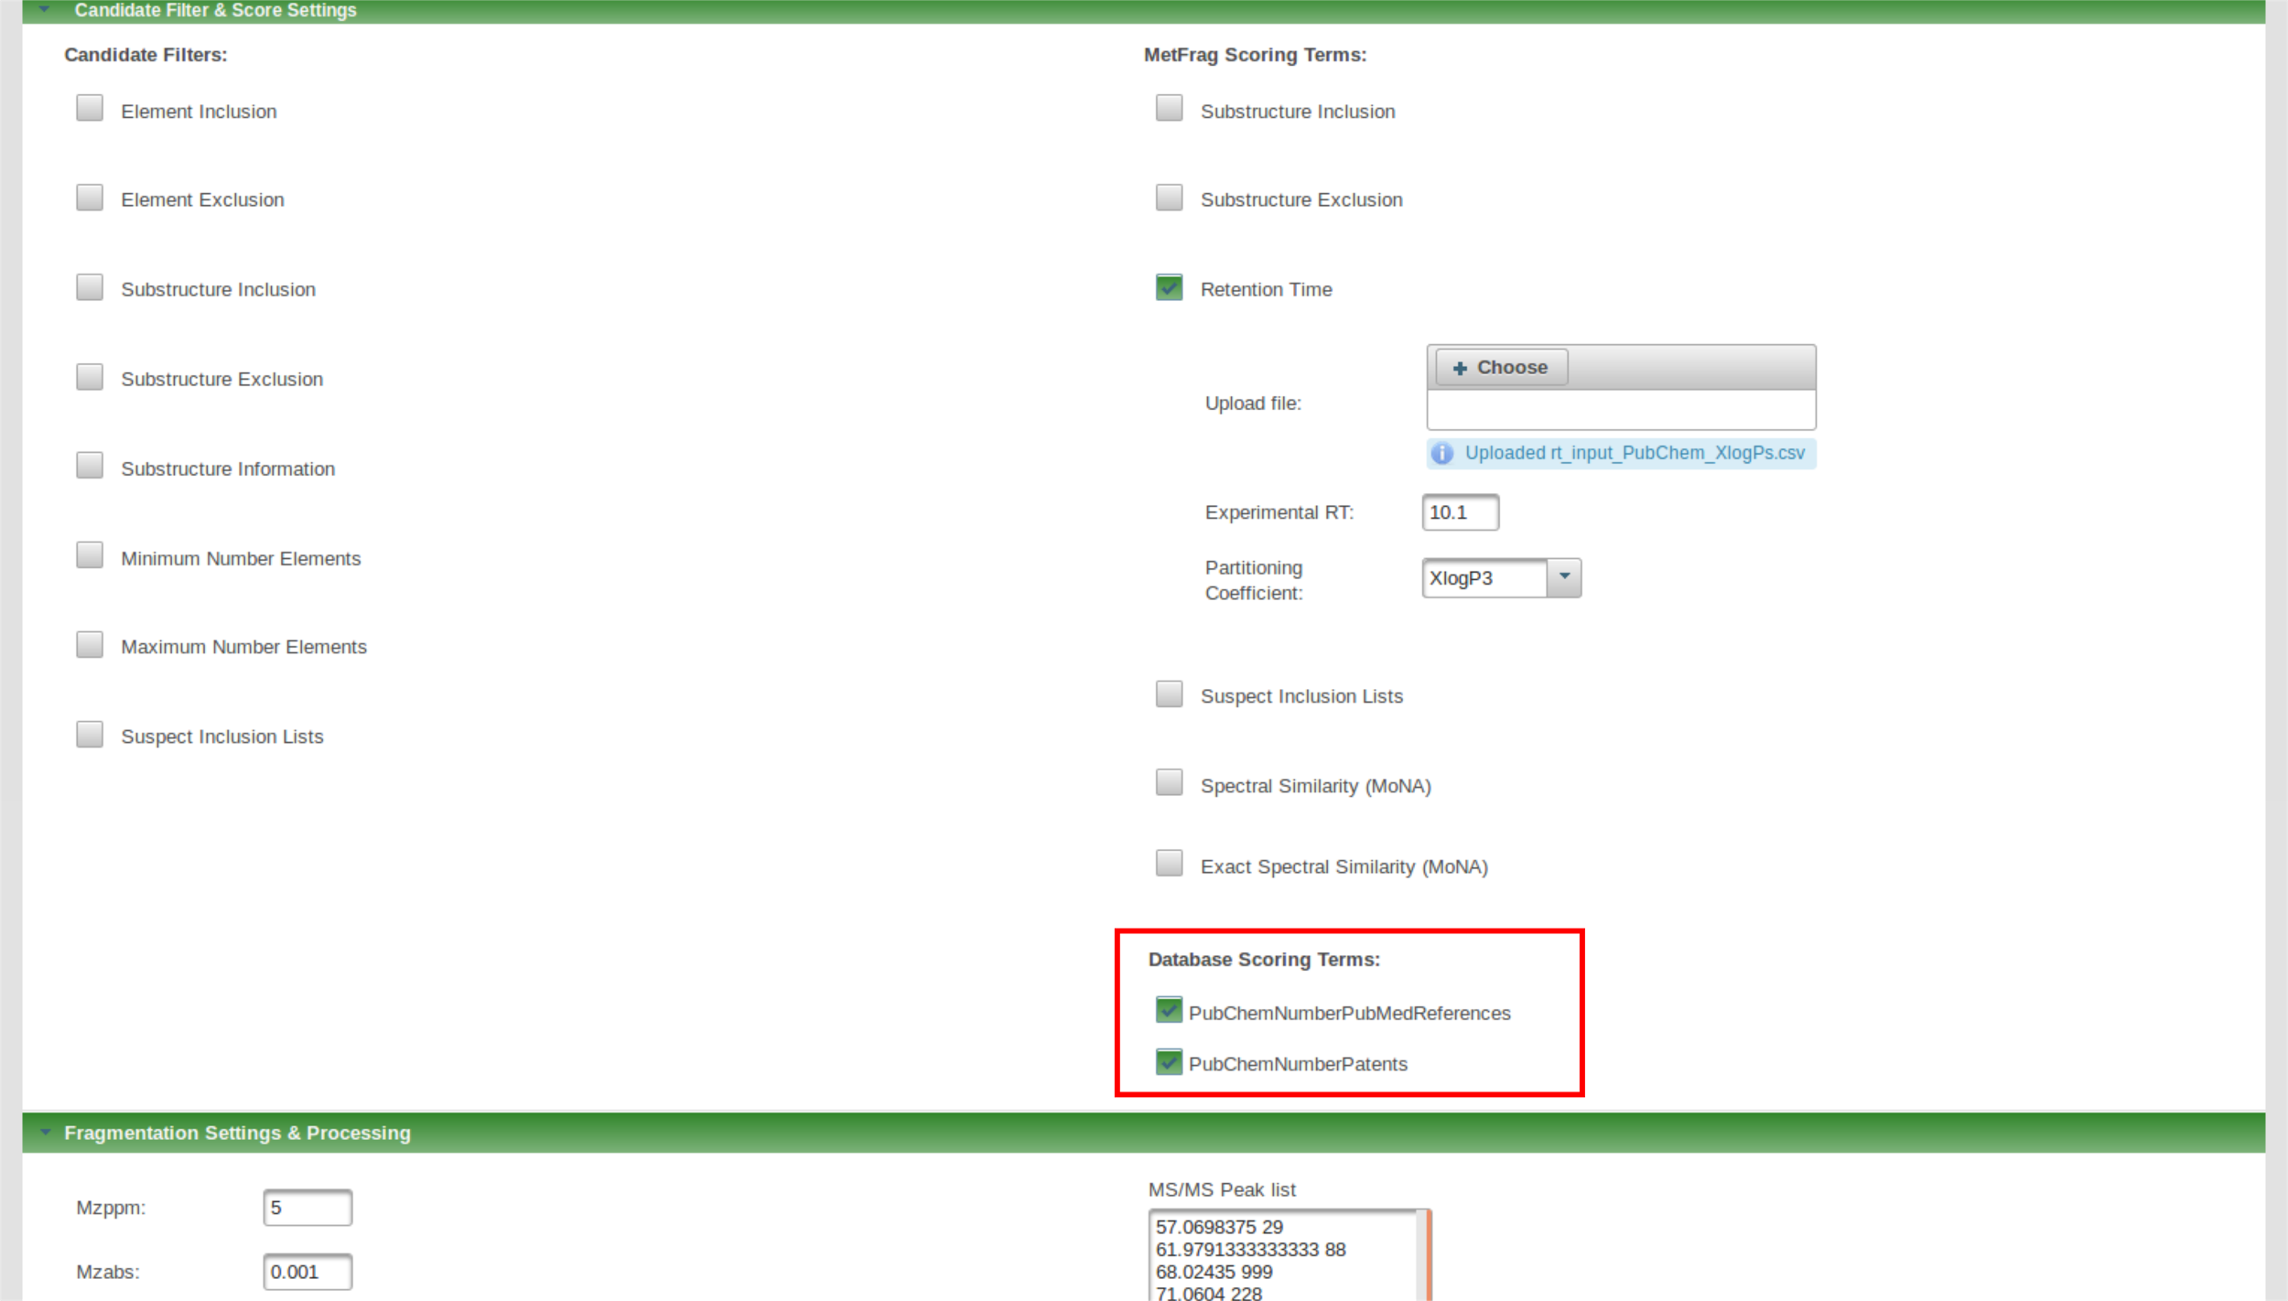

4 b) Process candidates by performing *in silico* fragmentation and matching to MS/MS data

* use the same settings as in 3 b) and process the candidates

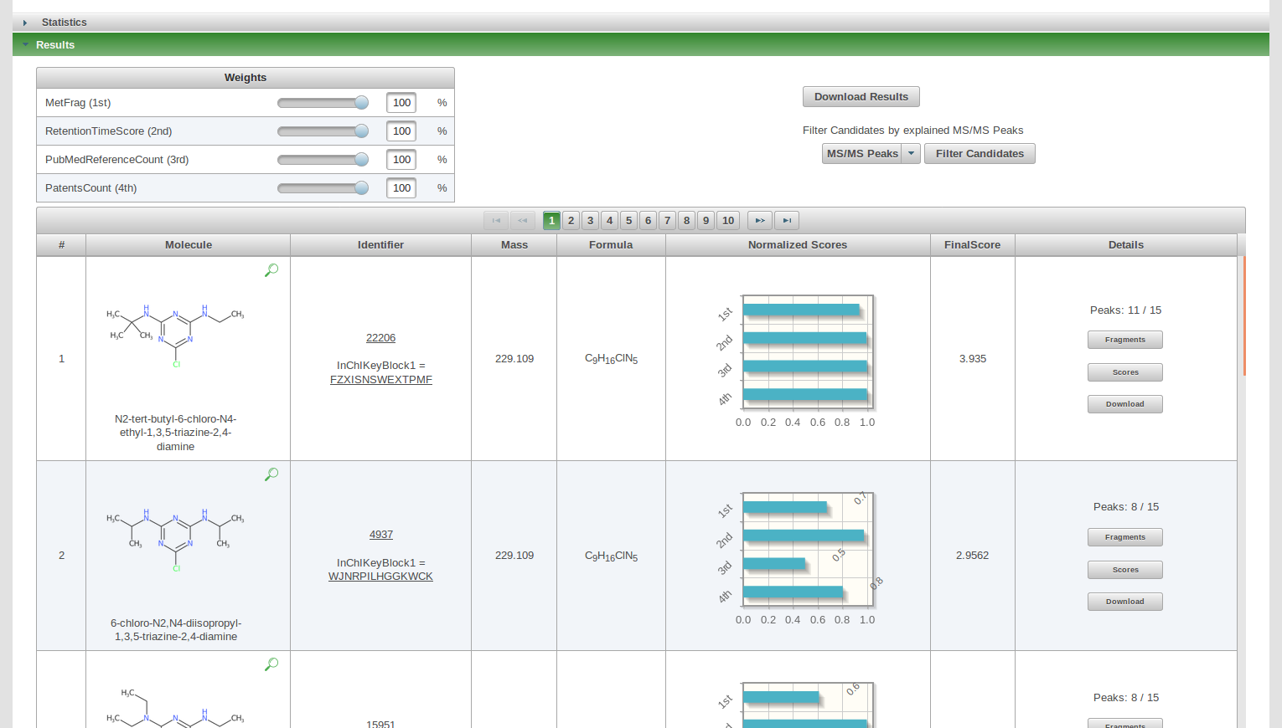

**Questions:**

Q8: What has changed compared to the previous run?

Q9: Would the number of references and patents have helped for a metabolomics experiment?

Q10: Investigate the high intensity fragments of the first ranked candidate? Are they plausible compared to fragment structures of other candidates?

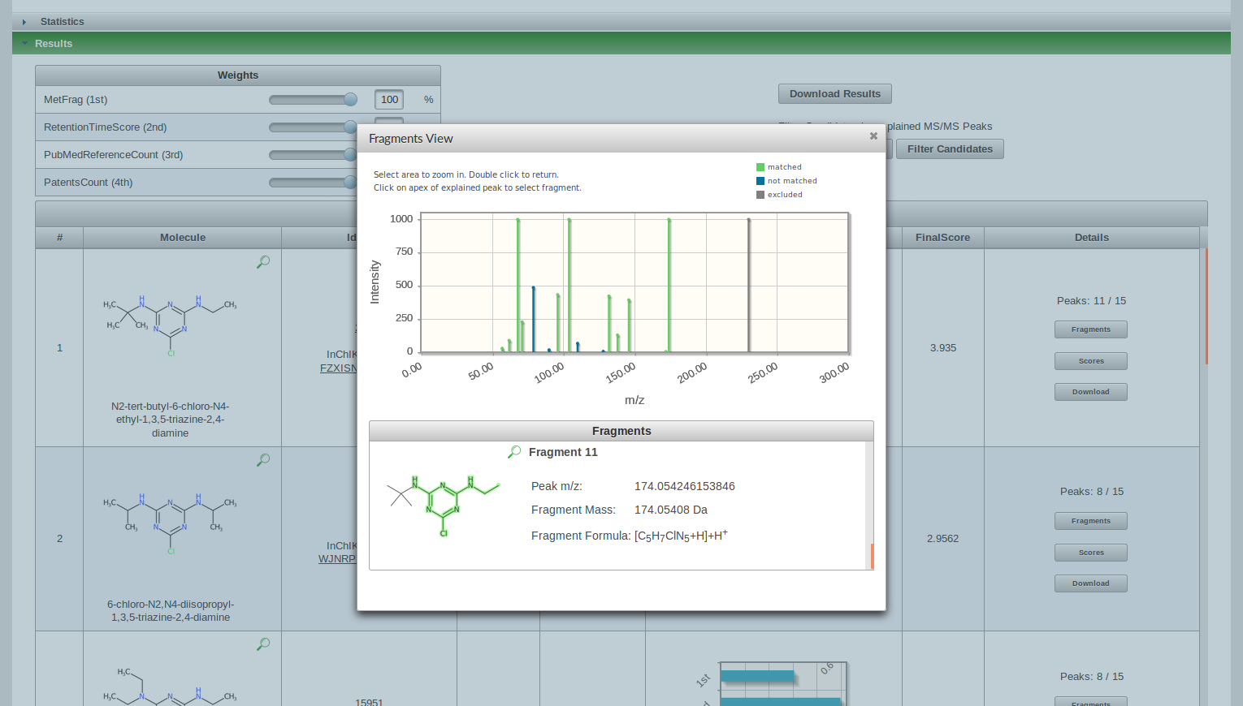

### 

### 

### 

### 

### 

### 

### 

### 

### 

### Step 5 - Search in spectral libraries

5 a) Investigate MS/MS peaks in MassBank

* visit MassBank EU (http://www.massbank.eu)
* select the “Peak Search” and add the most intense explained peaks

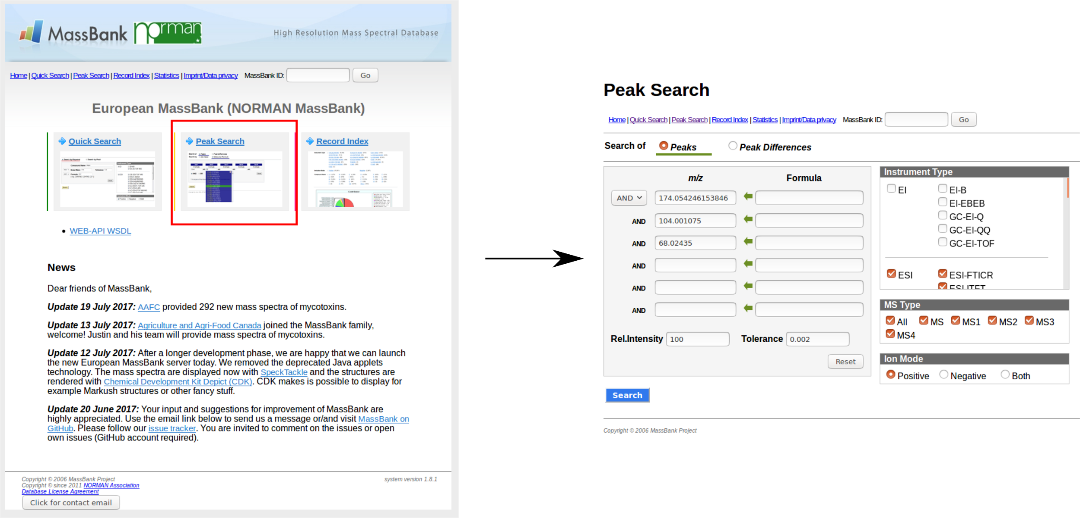

* hitting the “Search” button MassBank searches for spectra with matching peaks in the database

**Questions:**

Q11: Investigate the results and compare them to your MetFrag result list. Any conclusions?

### 

### 

### 

### 

### 

### 

### 

### Step 6 - Combine Spectra library search and MetFrag

6 a) Enable spectral similarity in MetFrag

* in the “Candidate Filter & Score Settings” tab enable “Spectral Similarity”
* MetFrag will now query the MS/MS peak list against a spectral library mirror to search for similar spectra of known compounds

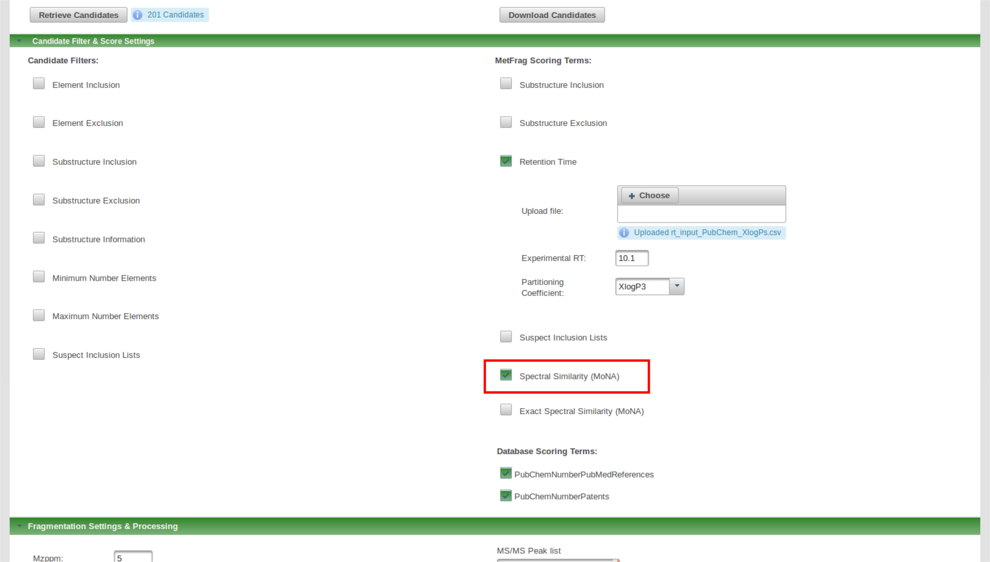

6 b) Process candidates by performing *in silico* fragmentation and matching to MS/MS data

* use the same settings as in 4 b) and process the candidates

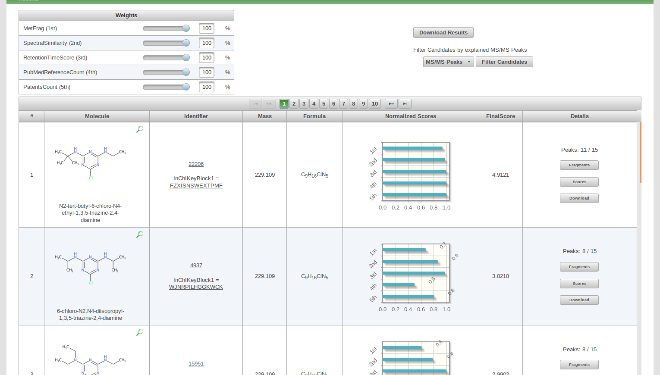

**Questions:**

Q12: Discard the meta information scores to just use the results based on experimental data. Any conclusions?